DAA LAB ACTIVITY-1
Name: Rathish P P
Roll no: CH.SC.U4CSE24238

1.Write a program to find sum of first n natural numbers using user defined function.
Code:
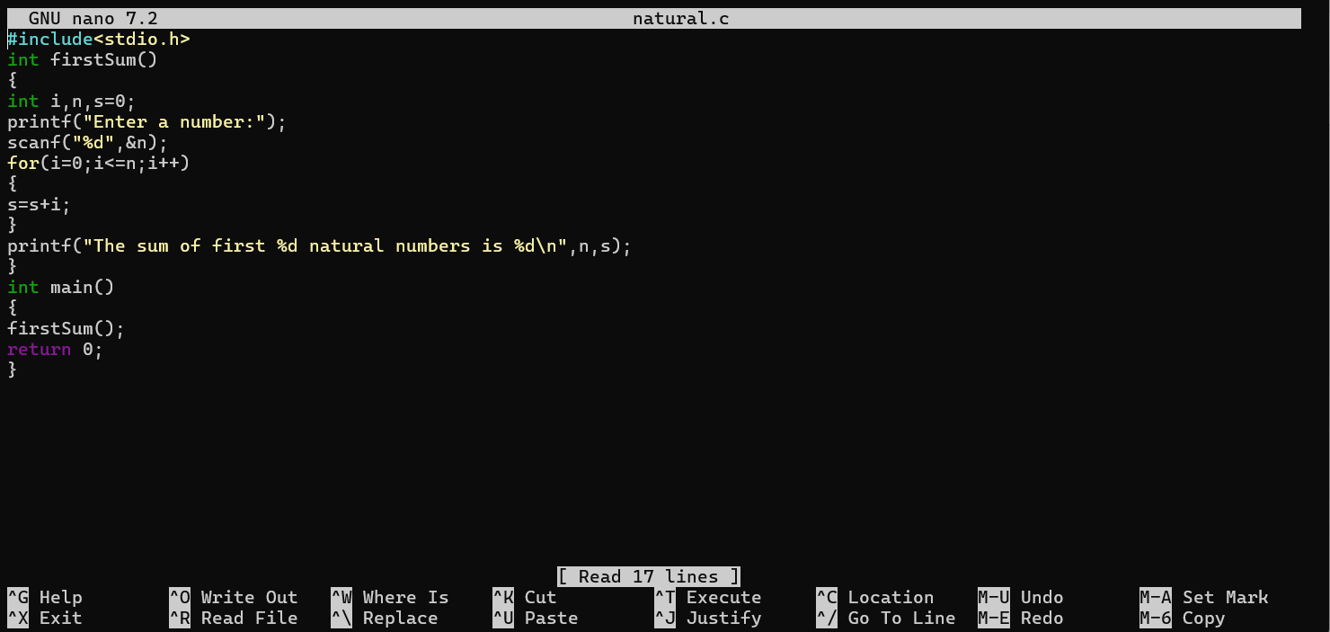
Output:
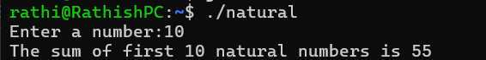
Inference:
In this code everything is done in the user defined function, and this function is called in the main function. So, the time complexity and space complexity is O(n).

2. Write a program to find the sum of squares of first n natural numbers using user defined function.
Code:
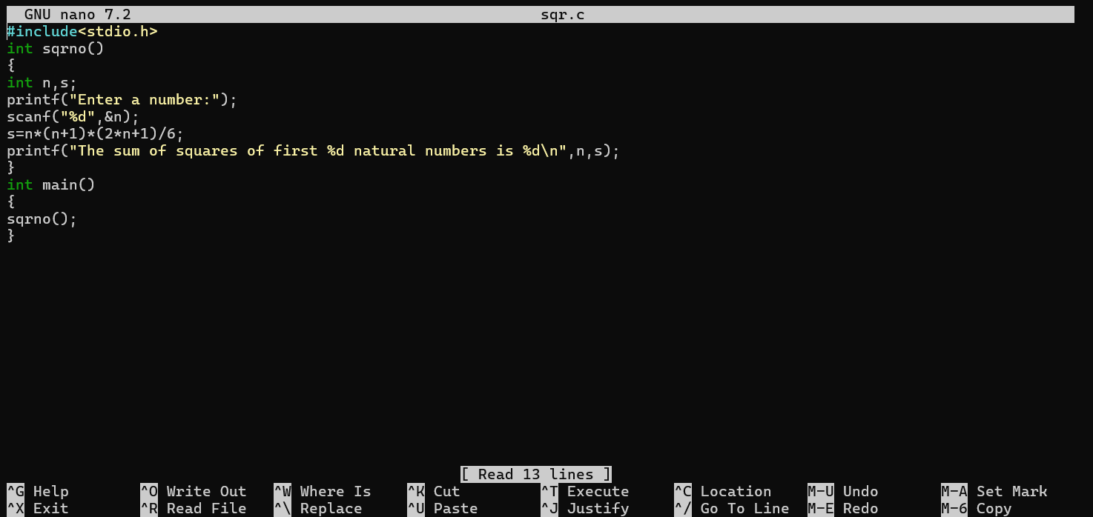
Output:
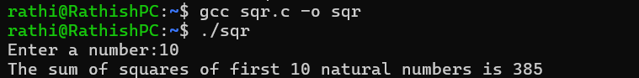
Inference:
The program has space and time complexity of O(1) instead of using for loop which has O(n) as time and space complexity.

3. Write a program to find the sum of cubes of first n natural numbers.
Code:
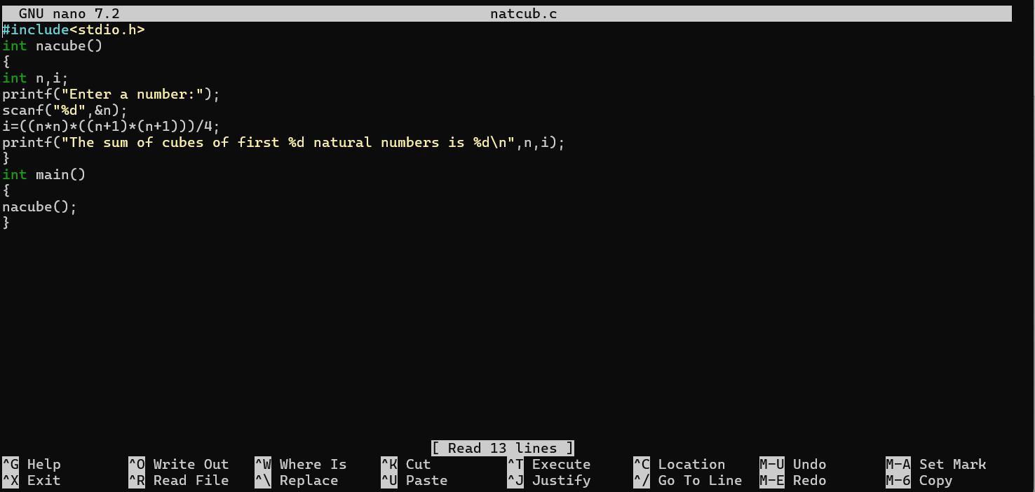
Output:
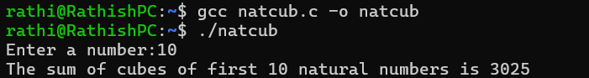
Inference:
The time and space complexity of the program is O(1) whereas it takes O(n) for using loop.

4. Write a program to find factorial of n natural numbers using recursive function.
Code:
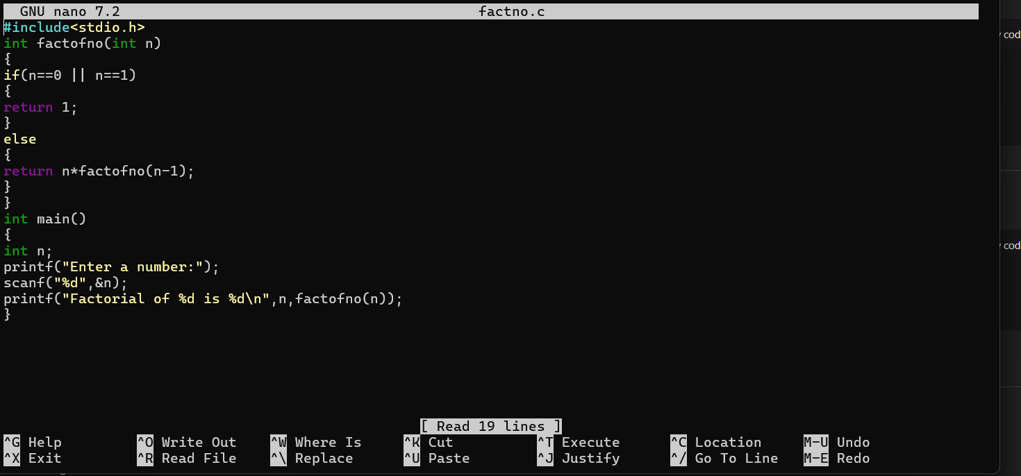
Output:
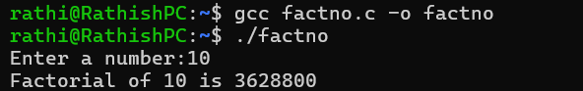
Inference:
The recursive function will call the function itself until the stopping condition is executed.

5. Write a program to find the transpose of 3*3 matrix.
Code:
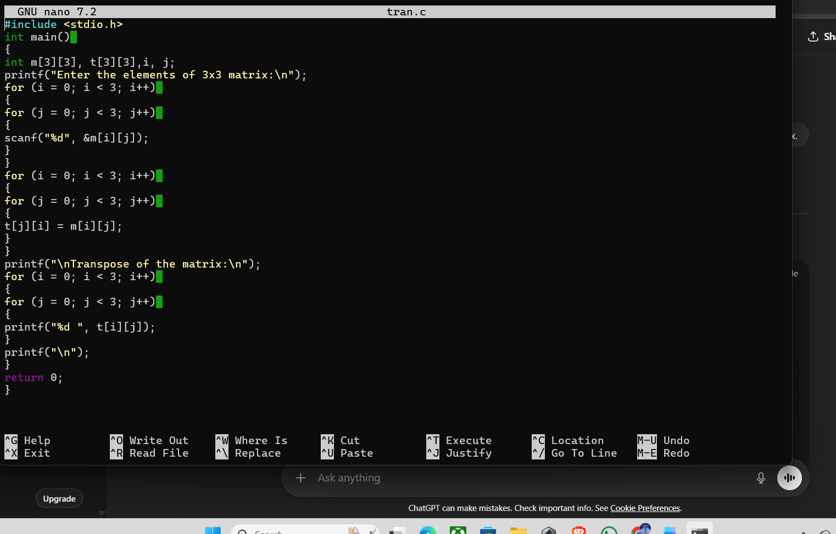
Output:
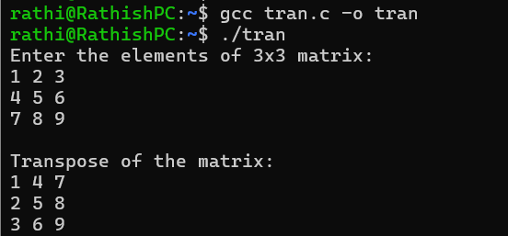
Inference:
The length of the for loop has been determined as 3. So the for loop will execute for 3 times.

6.Write a program to print the Fibonacci series of first n natural numbers using user defined function.
Code:
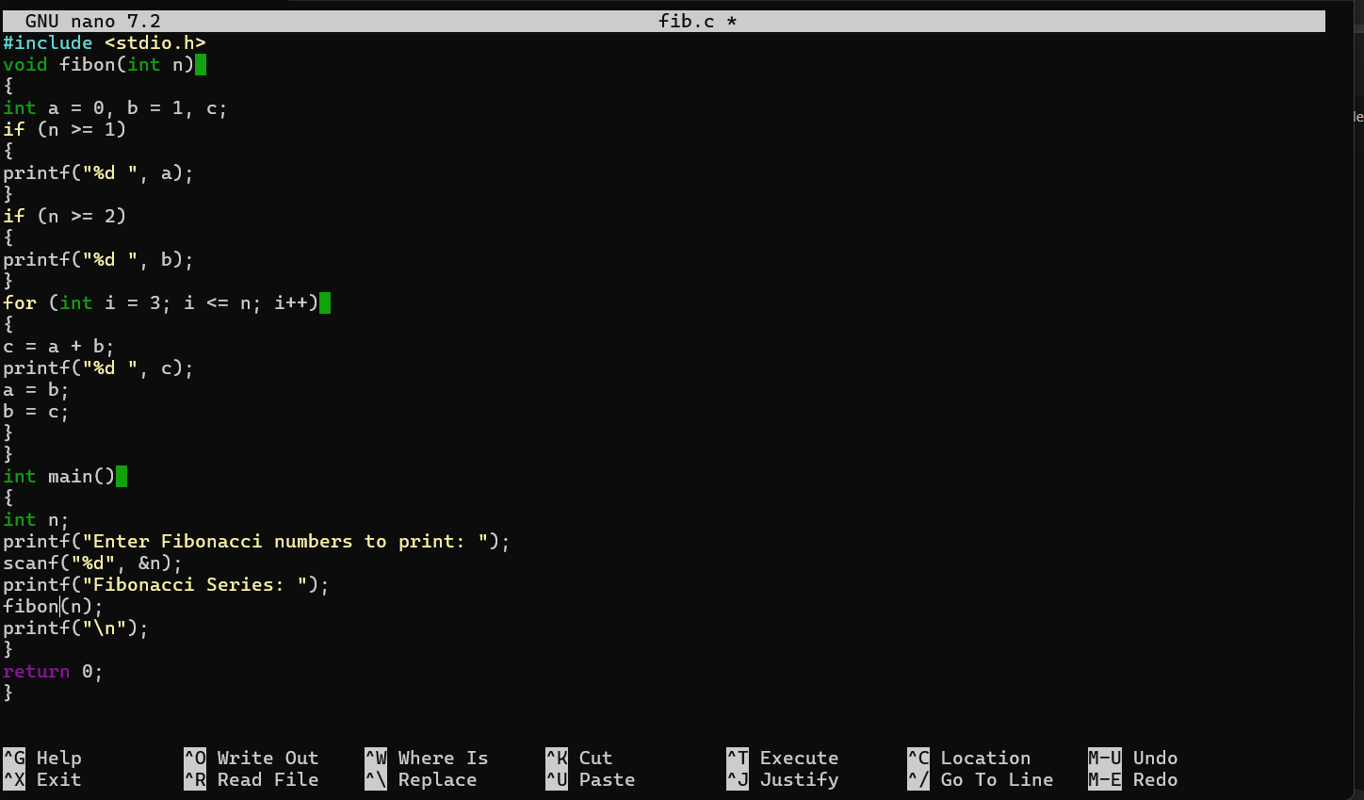
Output:
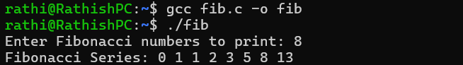
Inference:
The function will get the input from the main function and it will print the output inside the function itself.

